ENGR 4500 – H Bridge Design

An H Bridge Design consists of 4 Power MOSFET, where 2 of them turns on and the other 2 turns off, and a gate driver IC for each of the MOSFET. Here is an example schematic

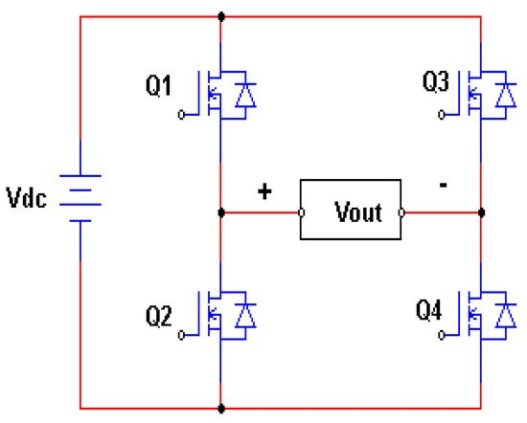

* Q1 and Q4 to turn on and Q2 and Q3 to turn off on 1 cycle
* And then Q1 and Q4 to turn off and Q2 and Q3 to turn on
* Avoid Q1 and Q2 (and Q3 and Q4) to simultaneously be on

Task to build an H Bridge

1. Build a PWM generator
2. Use a Half-Bridge Gate Driver IC to control the left-hand side of H Bridge
3. Repeat for control of the right-hand side of H-Bridge

PWM Generator

1. **TLC555/NE555**
2. **SN74HC04N**/CD74HC4049/74HC4049N (Hex Inverter)

Gate Driver

1. **IR2113**
2. **LM5100**
3. LMG1205
4. LT7061

Power MOSFET

1. **IRLZ44N**
2. **IPA029N06N**

PWM Generator Design 3

1st Design TLC555 Variant (GreatScott) 3

2nd Design NE555 (Astable Mode) 8

2nd Design TLC555 Variant (Astable Mode) 14

3rd Design ICM5555 21

H Bridge Gate Driver Design 23

Design 1: LM5101/IPA032N06N3 23

Design 2: LM5106/IPA032N06N3 27

Design 3: IRLZ44N/IR2113 36

# PWM Generator Design

## 1st Design TLC555 Variant (GreatScott)

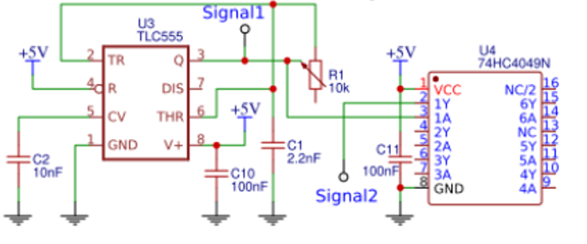

Ton: 47.4262m - 47.4133m = 0.0129m

Toff: 47.4419 - 47.4264m = 0.01555m

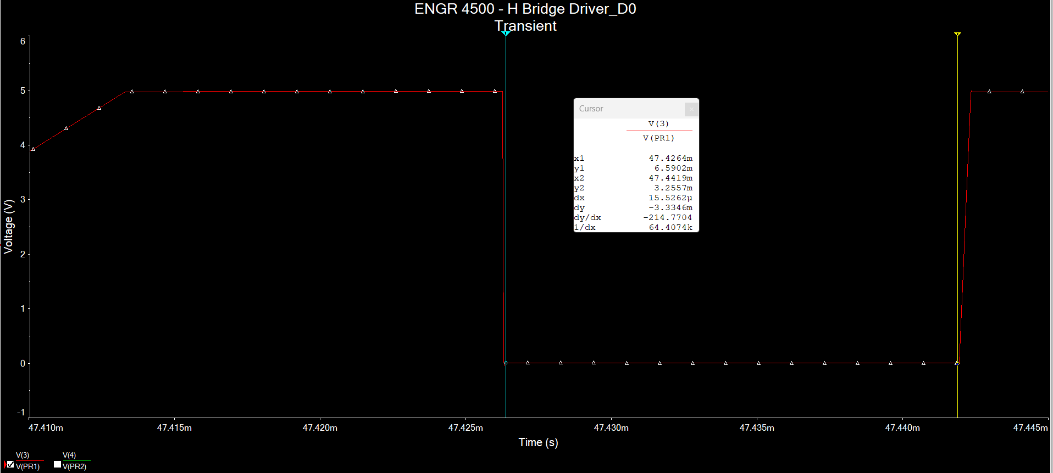

Period = 1/(Toff + Ton) = 1/(0.0129m+0.0155m) = 3.5211*10^4 Hz = 35.211kHz

Using cursors as measurement: 35.0383 kHz

Still first design but switch out the 10nF electrolytic and 2.2nF with regular capacitors

Ton: 41.4492m-41.4363m = 0.0129m

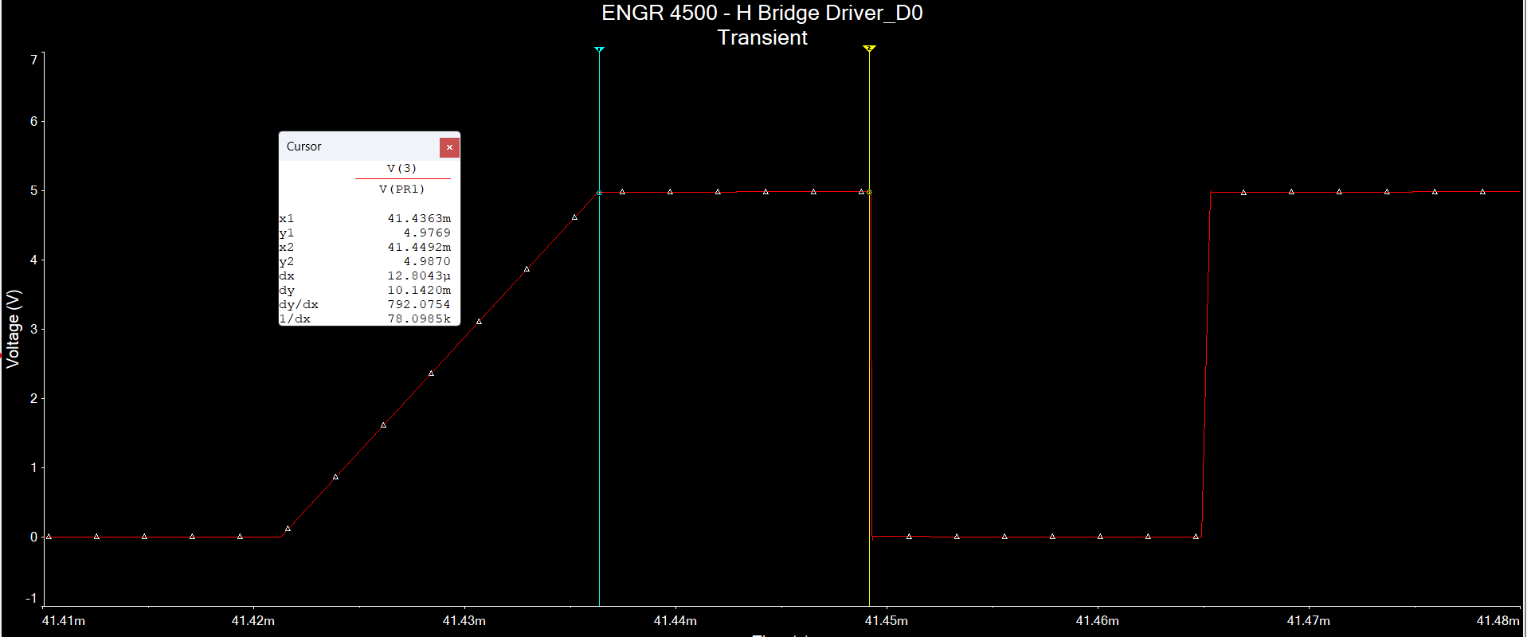

Toff: 41.4648m – 41.4493m = 0.0155m

Period: 1/(0.0129m+0.0155m) = 3.5211*10^4 Hz = 35.211kHz

Cursor measurement: 35.0615kHz

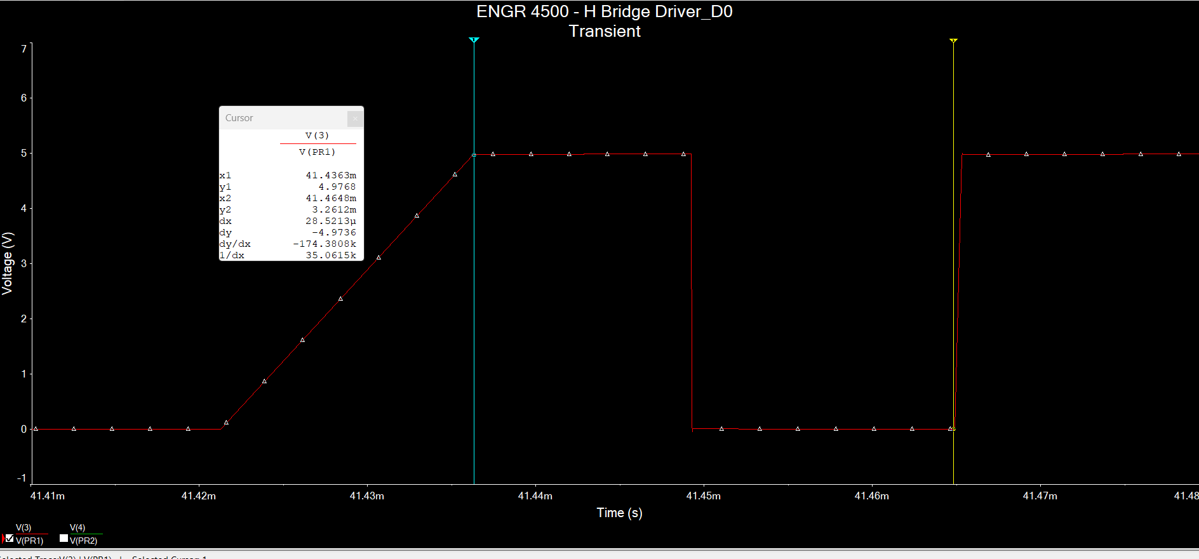

## 2nd Design NE555 (Astable Mode)

We can use the NE555 in astable mode using this schematic.

*Note: This circuit below only allows for 50% or higher Duty Cycle*

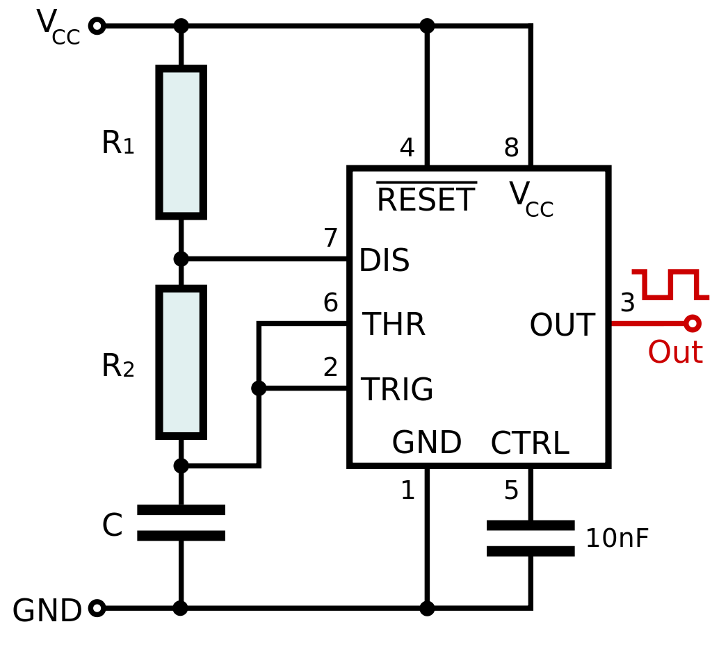

The frequency is defined as

$$f=\frac{1}{\ln{2}⋅\left(R_{1}+2R_{2}\right)⋅C}$$

The duty cycle is defined as

$$D=\frac{t_{high}}{t_{high}+t_{low}}⋅100=\frac{R_{1}+R_{2}}{R_{1}+2R_{2}}⋅100$$

The output high interval is defined as

$$t_{high}=\ln{2}⋅\left(R_{1}+R_{2}\right)⋅C$$

The output low interval is defined as

$$t_{low}=\ln{2⋅R_{2}}⋅C$$

We want a 100kHz PWM signal with a duty cycle of 50-55% to feed into the Gate Driver. Let us say $R_{1}=5kΩ$ and $R_{2}=25kΩ$. Determine C

$$f=\frac{1}{\ln{2}⋅\left(R_{1}+2R_{2}\right)⋅C}$$

$$C= \frac{1}{\ln{2 }⋅\left(5kΩ+2⋅25kΩ\right)⋅100kHz}=7.2399⋅{10}^{-6}F=7.24 nF$$

$$D=\frac{5kΩ+25kΩ}{5kΩ+50kΩ}⋅100=54.545\%$$

The capacitor value is not standard plus the Duty cycle is not ~52%. Let us redo our calculations but first determine the duty cycle

$$D=\frac{R_{1}+R_{2}}{R_{1}+2R_{2}}⋅100$$

Let $R_{1}=10kΩ, R_{2}=100kΩ$

$$D=\frac{10kΩ+100kΩ}{10kΩ+200kΩ}⋅100=52.3809\%$$

$$C=\frac{1}{\ln{2}⋅\left(10kΩ+100kΩ\right)⋅100 kHz}=1.3115*{10}^{-10}F=131.15pF$$

Still not standard but we are close to 100pF or 150pF standard values

From the Wikipedia page on 555 timer astable mode, there is actually a list of standard component values:

We can see that if we use R1 = 8.2k, R2 = 68k, and C = 100pF results in 52.8% duty cycle for a 100kHz signal

$$t_{high}=\ln{2}⋅\left(R_{1}+R_{2}\right)⋅C=\ln{2}⋅\left(8.2kΩ+68kΩ\right)⋅100pF=5.28176*{10}^{-6}s=5.28176μs$$

$$t_{low}=\ln{2 }⋅R_{2}⋅C=\ln{2}⋅68kΩ⋅100pF=4.713400827*{10}^{-6}s=4.7134μs$$

Simulation Results:

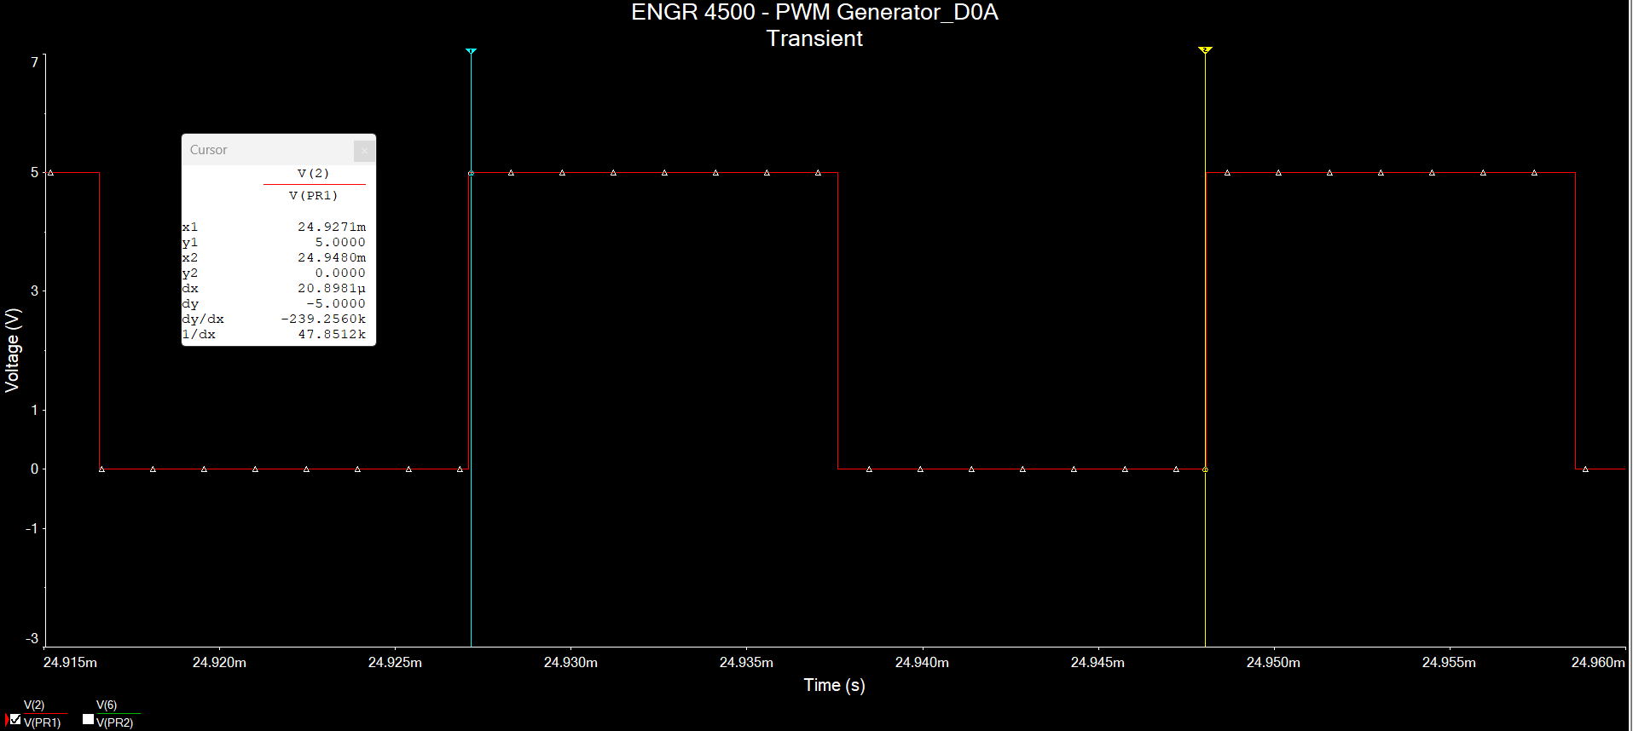

$$f=47.8512kHz$$

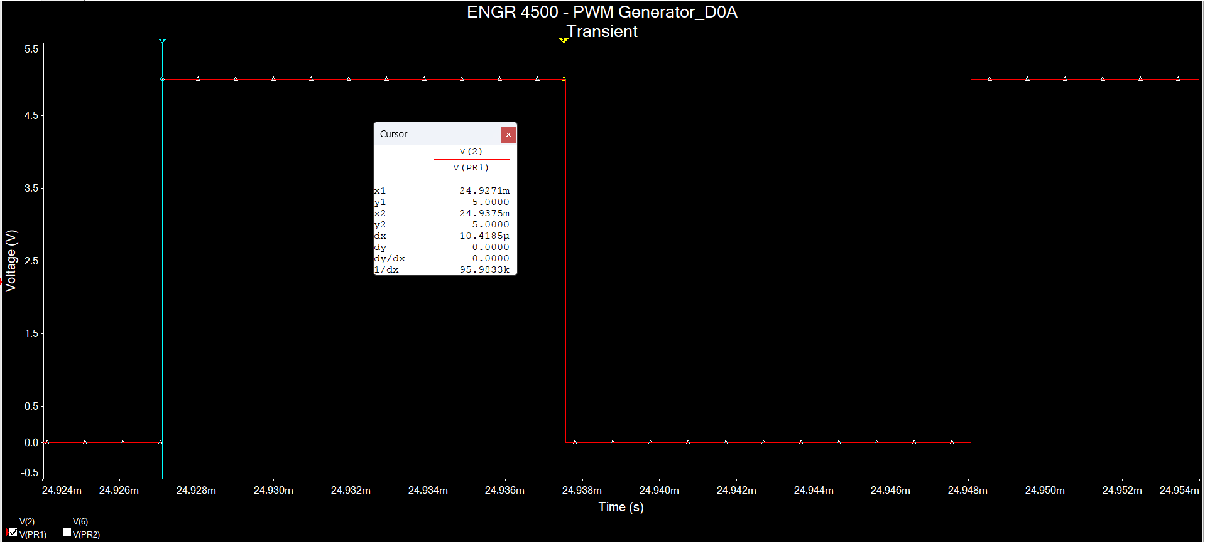

$$t_{high}=10.4185μs, f=95.9833kHz$$

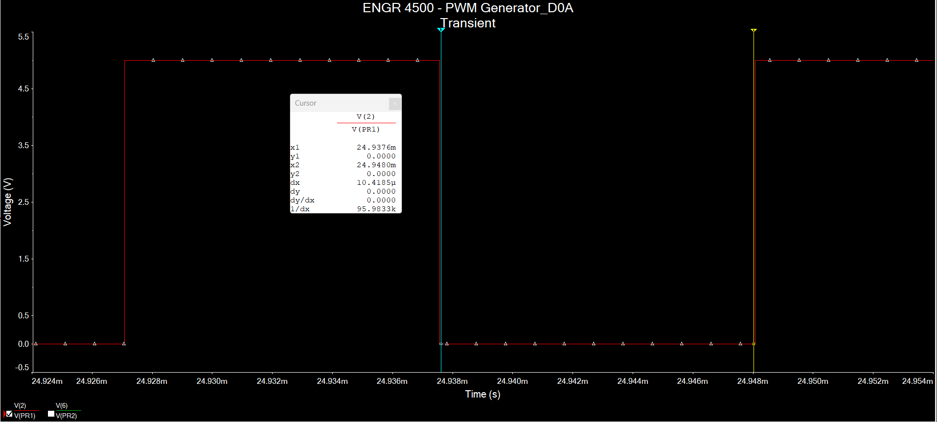

$$t_{low}=10.4185μs, f=95.9833kHz$$

But the interactive mode shows that the frequency is 89.4kHz

But changing R1 to 3.3k and R2 to 56k and keeping C1 results in a calculated frequency

$$f=\frac{1}{\ln{2}⋅\left(3.3kΩ+2⋅56kΩ\right)⋅100pF}=125.125kHz$$

Simulation results shows it is 108kHz

But with R1 = 7.5k and R2 = 68k and keeping C1 results in a calculated frequency of 100.536kHz

Simulation result shows it is 89.4kHz

R1 = 7.5k and R2 = 56k. Keep C1 results in a calculated frequency of 120.727kHz

Simulated results shows 101kHz

We should proceed with this rather than the 2nd or 3rd design for now

$$D=\frac{7.5kΩ+56kΩ}{7.5kΩ+2⋅56kΩ}⋅100=53.138\%$$

Part: [**RDE5C1H104J2K1H03B**](https://www.digikey.com/en/products/detail/murata-electronics/RDE5C1H104J2K1H03B/10691753) (0.1uF ceramic capacitor)

[**RDE5C1H101J0M1H03A**](https://www.digikey.com/en/products/detail/murata-electronics/RDE5C1H101J0M1H03A/4771115) (100pF ceramic capacitor)

[RDE5C1H103J1M1H03A](https://www.murata.com/en-us/products/productdetail?partno=RDE5C1H103J1M1H03A) (10nF ceramic capacitor)

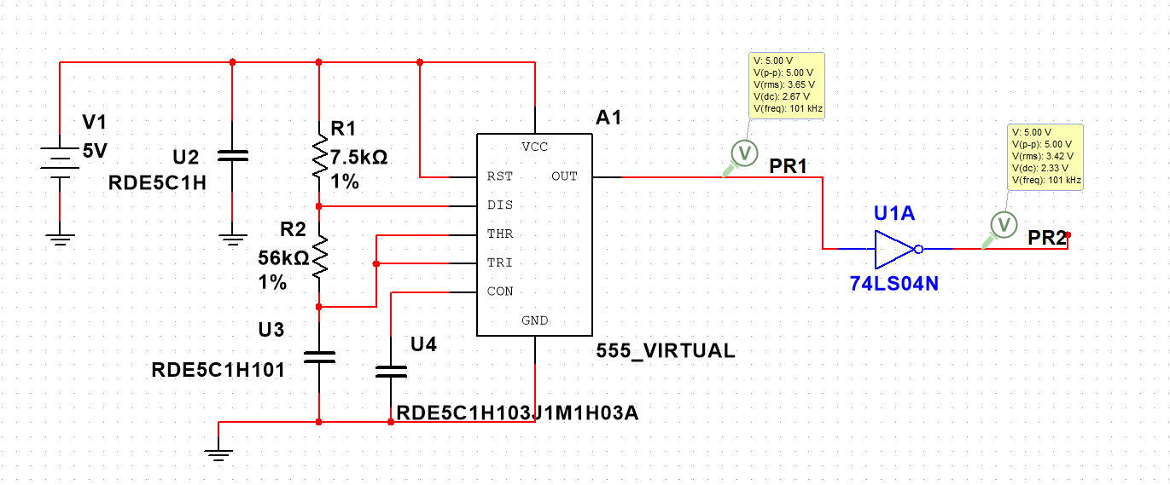

## 2nd Design TLC555 Variant (Astable Mode)

I attempted to use the TLC555 with the schematic meant for the NE555. These were the poor results

Noninverted Signal (f = 92.4623k)

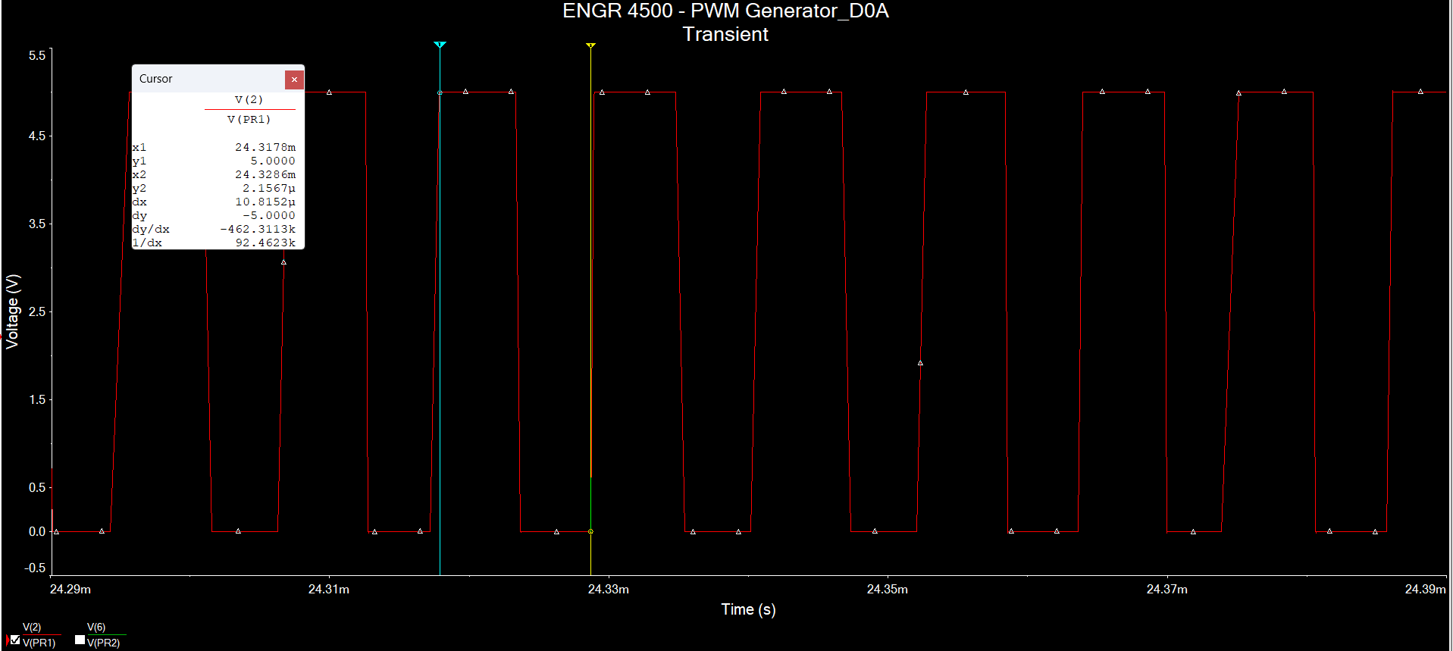

Inverted Signal Frequency (f = 92kHz)

Added a 0.1uF ceramic and 1uF electrolytic capacitors in parallel to the TLC555 (power supply requirement according to datasheet)

Noninverted Signal (f = 94.2816k)

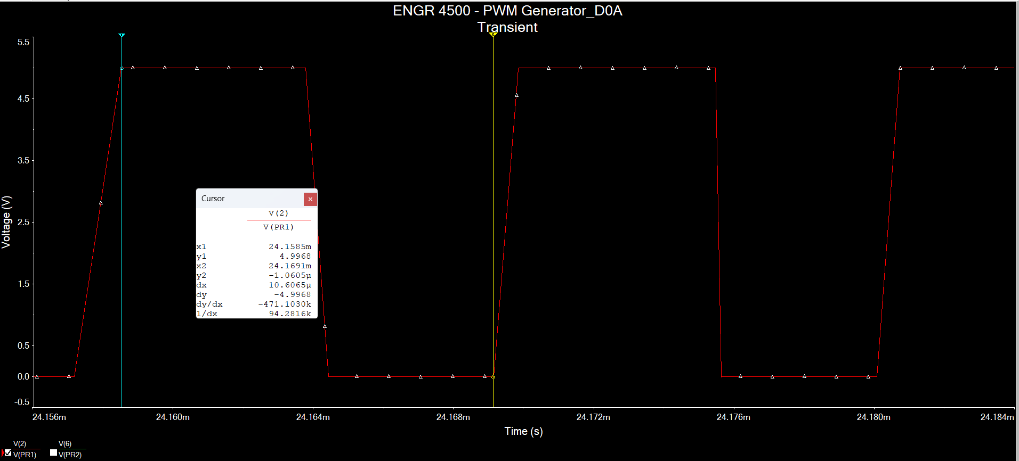

Inverted Signal (f = 89kHz)

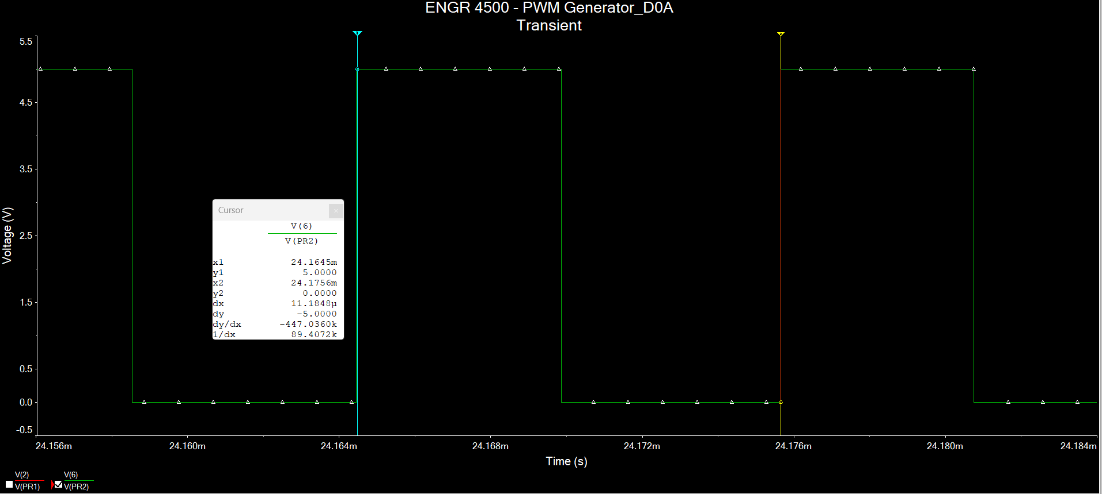

Instead, using this [source](https://e2e.ti.com/support/clock-timing-group/clock-and-timing/f/clock-timing-forum/879112/faq-how-do-i-design-a-stable-timer-oscillator-circuits-using-lmc555-tlc555-lm555-na555-ne555-sa555-or-se555) and the given equation to find the oscillation frequency

Rearranging the equation to find a suitable $R_{c}$

$$R_{c}=\frac{0.721}{f⋅C}$$

We know we want a 100kHz signal. We can also set C = 100uF

Simulation does not work

## 3rd Design ICM5555

General layout. We use (a) for 50% Duty Cycle

For a 50% duty cycle,

$$f=\frac{1}{1.4RC}$$

Let us generate a 100kHz PWM. Say $C=100nF$

$$R=\frac{1}{1.4fC}=\frac{1}{1.4⋅100kHz⋅100pF}=71.429kΩ$$

We can check if this works in Multisim

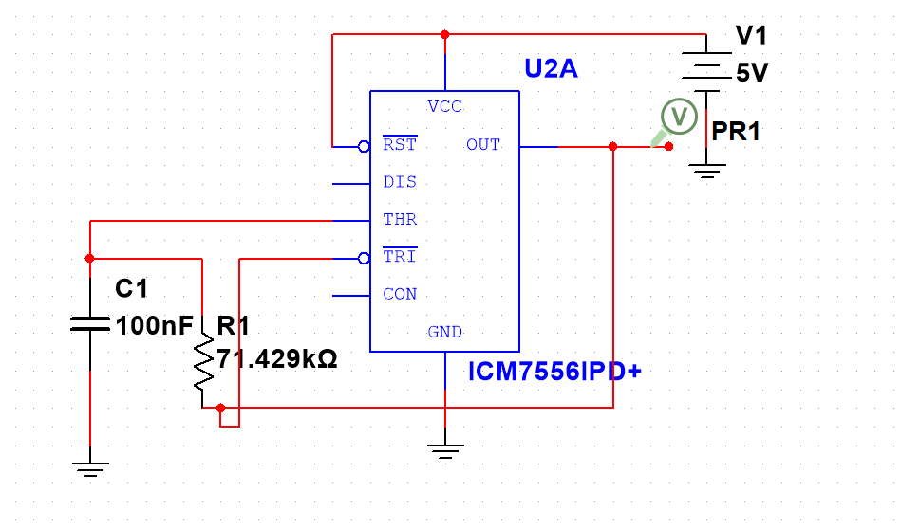

The simulation produce no waveform

# H Bridge Gate Driver Design

## Design 1: LM5101/IPA032N06N3

|  |  |
| --- | --- |
| Parameters | Value |
| Gate Driver | LM5101A |
| VDD | 10V |
| Qgmax | 52nC (datasheet of power mosfets) |
| fsw | 100kHz |
| Dmax | 60% |
| Vdh | 0.98V (datasheet of fast recovery diode) |
| Vhbr | 7.1V (datasheet of LM5101A) |
| Vhbh | 0.4V (datasheet of LM5101A) |

Select Bootstrap and VDD capacitor

* Bootstrap capacitor must maintain the HB pin voltage above the UVLO voltage for the HB circuit in any circumstances during normal operation

$$ΔV_{HB}=V_{DD}-V_{DH}-V_{HBL}$$

$$V_{HBL}=V_{HBR}-V_{HBH}=7.1V-0.4V= 6.7V$$

$$ΔV_{HB}=10V-0.98V-6.7V=2.32V$$

The quiescent current of the bootstrap circuit $(I_{HBS})$ must be 10uA max (from the datasheet of LM5101)

$$Q_{TOTAL}=Q_{gmax}+I_{HBS}⋅\frac{D_{Max}}{f_{SW}}=52nC+10μA⋅\left(\frac{0.60}{100kHz}\right)=5.2060*{10}^{-8}C=52.06nC$$

$$C_{BOOT}=\frac{Q_{TOTAL}}{ΔV_{HB}}=\frac{52.06nC}{2.32V}=2.244*{10}^{-8}F=22.44nF$$

In practice, the bootstrap capacitor should be greater than the calculated value above to account for the power stage skipping a pulse due to load transients

$$C_{BOOT}=100nF$$

The local VDD bypass capacitor should be 10x the above value

$$C_{VDD}=10C_{Boot}=10⋅100nF= 1μF$$

Note: Bootstrap and Bias Capacitors should be ceramic types with X7R dielectric

* Voltage rating must be 2x maximum VDD to account for loss over capacitance
  + In this case, 2x10V = 20V

Select External Bootstrap Diode and Resistor

* Bootstrap capacitor is charged by the VDD through the internal bootstrap diode every cycle when LS MOSFET turns on
  + Charging the capacitor involves high peak currents and the power dissipation in the internal bootstrap diode may be significant
  + For high frequency and high capacitive loads, it may be necessary to consider an external bootstrap diode in parallel with internal bootstrap diode to reduce power dissipation
* Examine Application Note  [SNVA083.](https://www.ti.com/lit/an/snva083b/snva083b.pdf?ts=1665259176240)

The power dissipation through the gates

$$P_{DGATES}=2fC_{L}V_{DD}^{2}=2fQ_{G}V_{DD}=2\left(100kHz\right)\left(52.0nC\right)\left(10V\right)=0.1040W$$

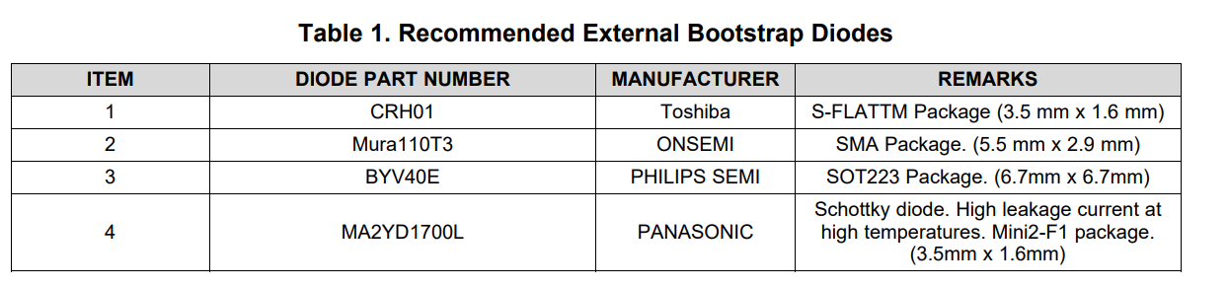

All of these are not available at Mouser. Only CRH01 and BYV40E is available at digikey. CRH01 has a pspice file

We will use the external bootstrap diode once we have the full transmitter network

* The Bootstrap resistor is selected to reduce the inrush current in Dboot. Recommended bootstrap resistor size is between 2 ohms and 10 ohms. Let us select 2.2 ohms

$$I_{DBOOT\left(pk\right)}=\frac{V_{DD}-V_{DBOOT}}{R_{BOOT}}=\frac{10V-0.6V}{2.2Ω}=4.27A$$

Select Gate Driver Resistor

* Gate Driver Resistor is sized to reduce ringing caused by parasitic inductances and capacitances and limit the current coming out of the gate driver.
* Use 4.7-ohm resistors. VOH is 0.45V and VOL is 0.25V (from datasheet)

$$I_{HOH}=\frac{V_{DD}-V_{DH}-V_{OH}}{R_{GATE}}=\frac{10V-0.98V-0.45V}{4.7Ω}=1.8234A$$

$$I_{LOH}=\frac{V_{DD}-V_{OH}}{R_{GATE}}=\frac{10V-0.45V}{4.7 Ω}=2.0319A$$

$$I_{HOL}=\frac{V_{DD}-V_{DH}-V_{OL}}{R_{GATE}}=\frac{10V-0.98V-0.25V}{4.7Ω}=1.8660A$$

$$I_{LOL}=\frac{V_{DD}-V_{OL}}{R_{GATE}}=\frac{10V-0.25V}{4.7Ω}=2.0745A$$

Estimate the driver power losses

$$P_{DGATES}=2V_{DD}^{2}C_{L}f_{SW}= 2fQ_{G}V_{DD}=2\left(100kHz\right)\left(52.0nC\right)\left(10V\right)=0.1040W$$

Allowable IC power loss (where Tj is junction temperature, Ta is ambient temperature, and Rja is the junction to ambient thermal resistance)

$$P_{LOSS}=\frac{T_{J}-T_{A}}{R_{θJA}}=\frac{125°C-25°C}{37.8\frac{°C}{W}}=2.6455W$$

Therefore our component list is

|  |  |  |
| --- | --- | --- |
| Part | Component Value | Manufacturer |
| Bootstrap Capacitor (Ceramic X7R) | 100nF (0.1uF) | RDER71H104K0M1H03A  Murata |
| Bypass Capacitor (Ceramic X7R) | 1uF | RDER71H105K2M1H03A  Murata |
| External Fast Recovery Diode |  |  |
| Bootstrap Resistor | 2.2 ohm (10W) | 40J2R2E by Ohmite |
| Gate Driver Resistor | 4.7 ohm (10W) | 30J4R7E by Ohmite |

Schematic:

Simulation Result: N/A (Subckt error on the LM5101A model itself)

## Design 2: LM5106/IPA032N06N3

|  |  |
| --- | --- |
| Parameters | Values |
| Gate Driver IC | LM5106 |
| VDD | 10V |
| Qgmax | 53nC |
| fsw | 100kHz |
| Dmax | 60% |
| Ihbo | 10uA |
| VDh | 0.98V |
| VHBR | 7.3V |
| VHBH | 0.4V |

*Select Bootstrap and VDD capacitor*

$$ΔV_{HB}=V_{DD}-V_{DH}-V_{HBL}$$

$$V_{HBL}=V_{HBR}-V_{HBH}=7.3V-0.4V=6.9V$$

$$ΔV_{HB}=10V-0.98V-6.9V=2.12V$$

$$C_{BOOT}=\frac{Q_{TOTAL}}{ΔV_{HB}}$$

$$Q_{TOTAL}=Q_{gmax}+I_{HBO}×\frac{D_{MAX}}{f_{sw}}$$

$$Q_{TOTAL}=52nC+10μA×\frac{0.60}{500kHz}=5.2012⋅{10}^{-8}C=52.012nC$$

$$C_{BOOT}=\frac{52.012nC}{2.12V}=2.4534⋅{10}^{-8}F=24.534nF$$

Just like for LM5101 the bootstrap capacitor should be greater than calculated values to account for transients

$$C_{BOOT}=100nF$$

And just like LM5101 the bypass capacitor should be 10x greater than the bootstrap capacitor

$$C_{VDD}=10C_{Boot}=10⋅100nF=1μF$$

And just like LM5101, the bootstrap and bypass capacitor should be ceramic X7R type with voltage rating twice the allowed VDD

*Selecting Resistor Values for Deadtime*

* Use Figure 19 from Datasheet

Let us set a deadtime of 500ns. We may need to adjust this later in the simulation

$$t_{DEAD}=500ns→90kΩ$$

*Select Gate Resistor*

* Not in the LM5106 datasheet but we can use the procedure from LM5101
* Let us use a 4.7-ohm resistor. Voh is 0.85V and Vol is 0.4V

$$I_{HOH}=\frac{V_{DD}-V_{DH}-V_{OH}}{R_{GATE}}=\frac{10V-0.98V-0.85V}{4.7Ω}=1.7383A$$

$$I_{LOH}=\frac{V_{DD}-V_{OH}}{R_{GATE}}=\frac{10V-0.85V}{4.7 Ω}=1.9468A$$

$$I_{HOL}=\frac{V_{DD}-V_{DH}-V_{OL}}{R_{GATE}}=\frac{10V-0.98V-0.4V}{4.7Ω}=1.8340A$$

$$I_{LOL}=\frac{V_{DD}-V_{OL}}{R_{GATE}}=\frac{10V-0.4V}{4.7Ω}=2.0426A$$

*Power Dissipation Considerations*

$$P_{DGATES}=2×f×C_{L}×V_{DD}^{2}=2×f×Q_{G}×V_{DD}=2\left(100kHz\right)\left(52.0nC\right)\left(10V\right)=0.1040W$$

*Select External Diode*

* Does not have information from LM5106 Datasheet. But we can use the LM5101 datasheet as a guideline. Let us use the CRH01 for LM5106

Parts List

|  |  |  |
| --- | --- | --- |
| Part | Value | Manufacturer |
| Bootstrap Capacitor (Ceramic X7R) | 100nF (0.1uF) | RDER71H104K0M1H03A  Murata |
| Bypass Capacitor (Ceramic X7R) | 1uF | RDER71H105K2M1H03A  Murata |
| External Fast Switch Diode | 200V 1A 34ns reverse time | CRH01 by Toshiba |
| Deadtime Resistor | 90kOhms 1% 0.5W | CMF5590K000BHEB by Vishay |
| Gate Resistor | 4.7 ohm (10W) | 30J4R7E by Ohmite |
| MOSFET Filter Capacitor | 100uF | KCM55WC71E107MH13 by Murata |

Schematic:

Simulation (of LHS):

Simulate with Complimentary PWM signal (RHS)

Now add in HHSD630ELL101MJC5S for the 100uF capacitor and see how it behaves

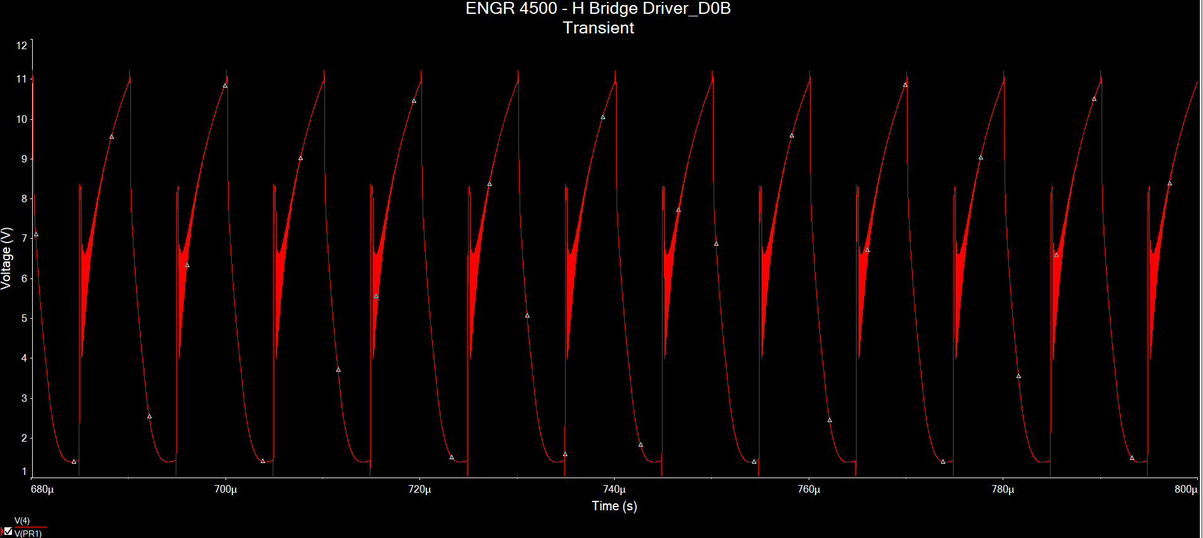

This aluminum organic hybrid capacitor is no good. Try a different one

Try EMZR350ARA101MF61G an aluminum electrolytic capacitor

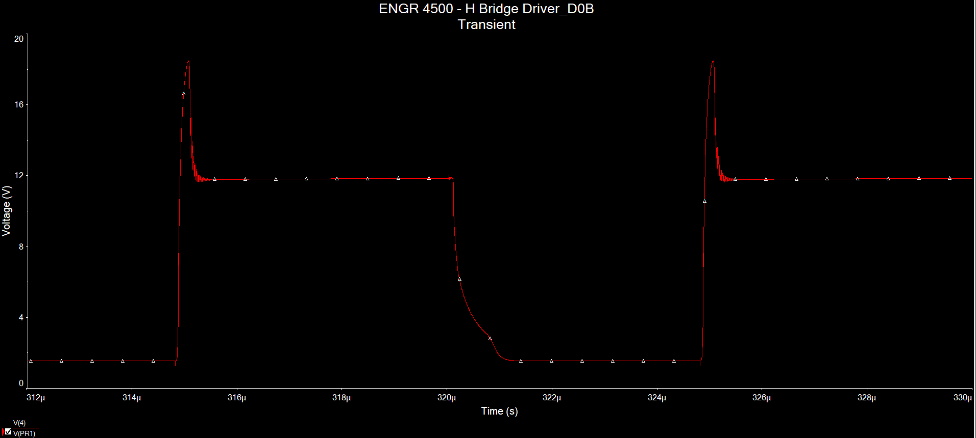

Not good either. Try a ceramic capacitor KCM55WC71E107MH13 from Murata

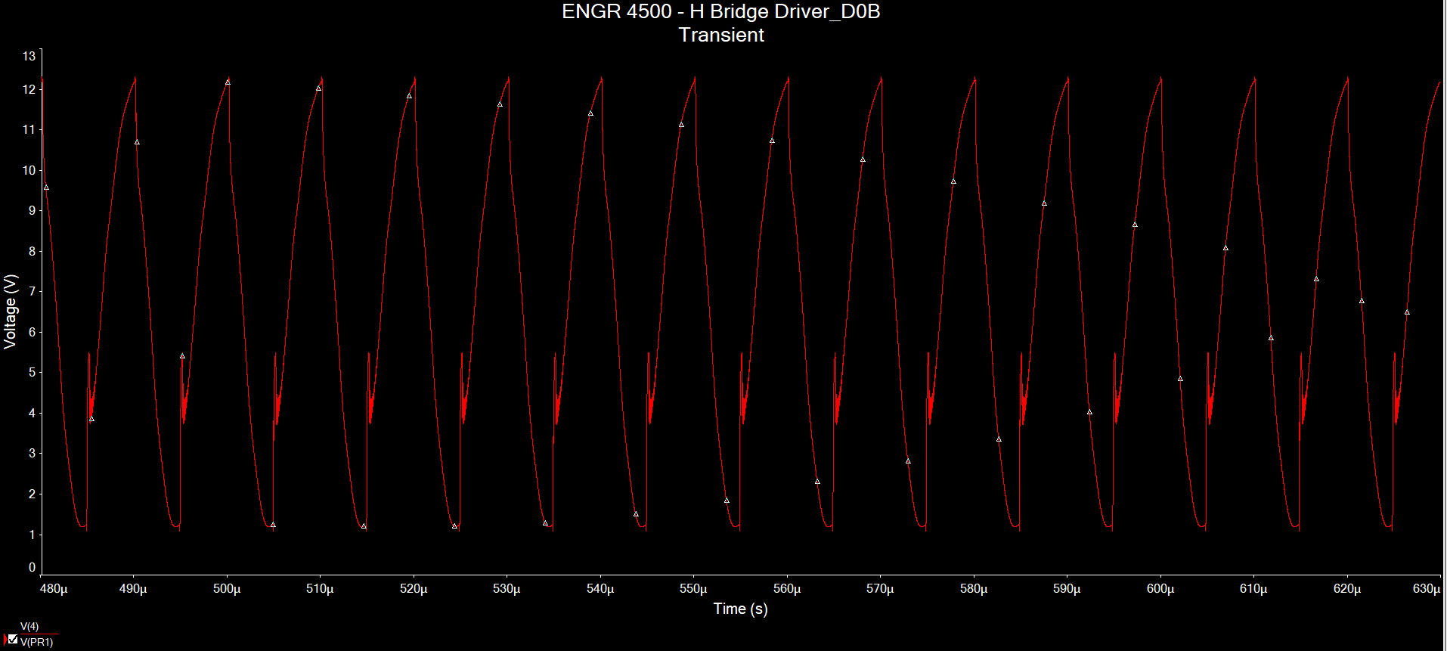

Imperfect Sinusoidal Wave – looks better than the aluminum electrolytic capacitors

Now combine LHS and RHS into one Full Bridge Inverter

Simulation Results

## Design 3: IRLZ44N/IR2113

Using GreatScott H-Bridge Inverter design from his DIY Wireless Power Transfer video

We can replace the LM7805 with a 5V DC source for simulation purposes only. Also replace the TLC555 and 74HC4049N (constitutes the PWM generator) with PWM_Complementary component from Multisim. As a result, this is the simulation circuit schematic:

The part in this simulation are RDER71H104K0M1H05A (100nF ceramic capacitor), RCEC71H106K3A2H03B (10uF ceramic capacitor), and UF4007 (fast recovery diode)

# Integration

## Design 3: IRLZ44N/IR2113

This is the schematic

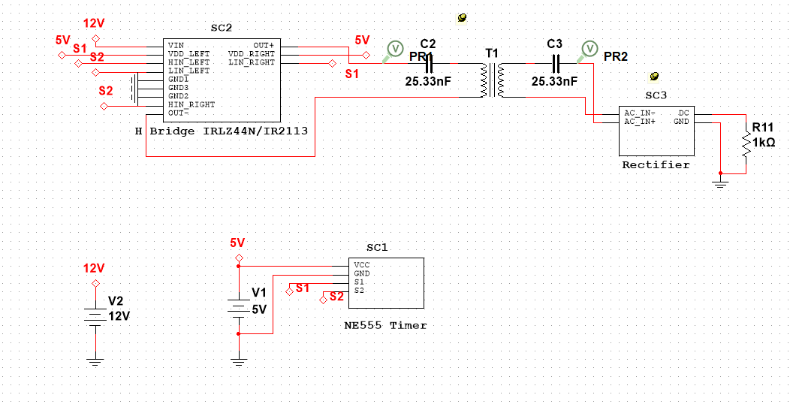

Try to probe the voltage before the transmitter capacitor shows that it is a PWM wave with 100kHz (this is good!)

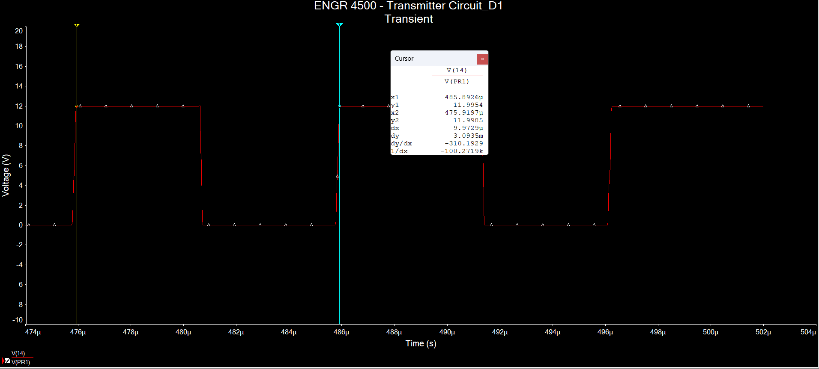

But the voltage on the load is rising which means the full power is not reaching it (not good!)

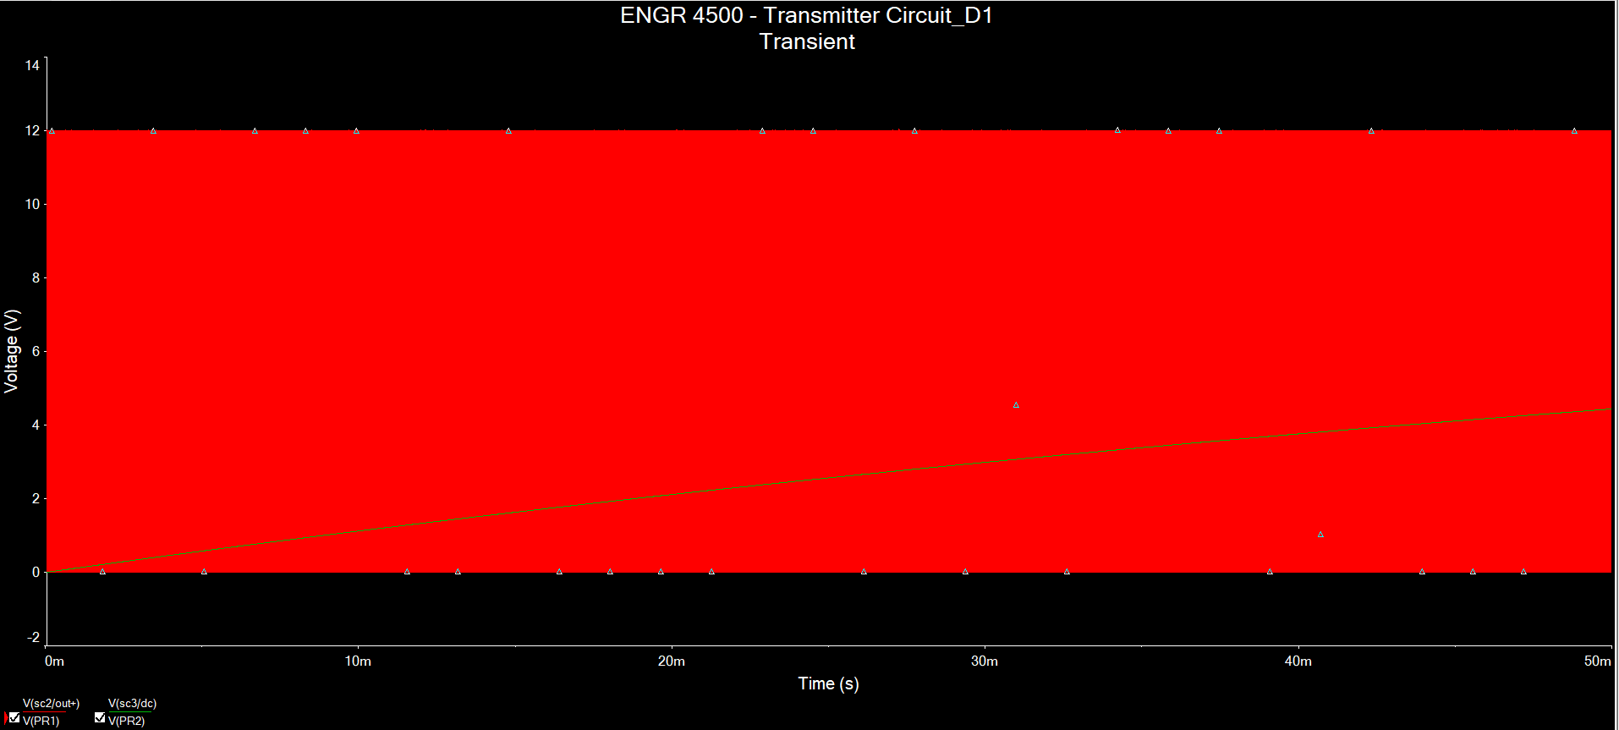

Probing the transformer results in a somewhat sinusoidal pattern but there is this charge/discharge ripple (not good!)

Inspecting the waveform of the output of the H bridge (Out+ and Out-) shows PWM in complementary fashion (really good!)

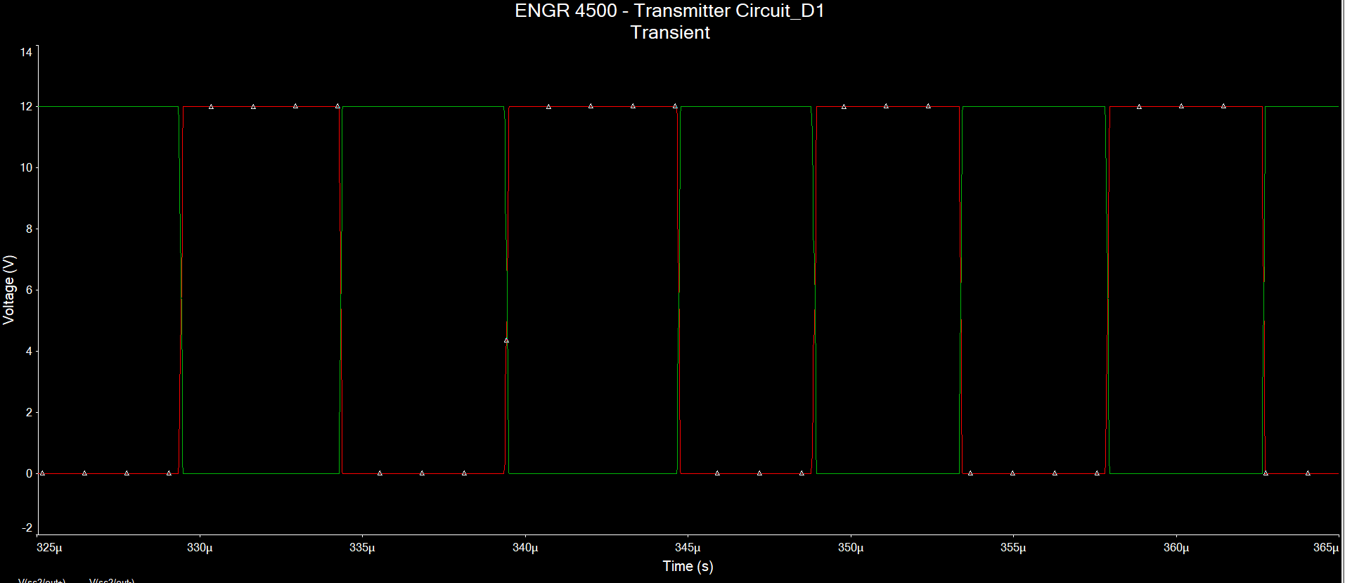

This is probing the before Tx cap and after Rx cap which produce a almost sinusoidal curve but there is this ringing at the peak which comes from the inductor (not good!)

# Testing

## Checking the Rectifier Circuit

Schematic (Vrms = 0.707Vpk = 0.707(12) = 8.484Vrms)

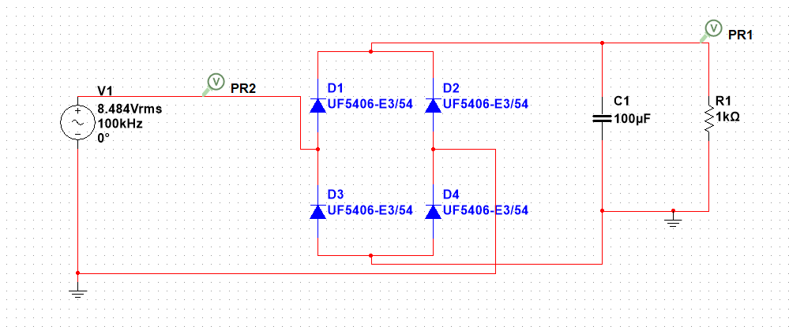

Simulation Result (rectified the voltage to 10.65V)

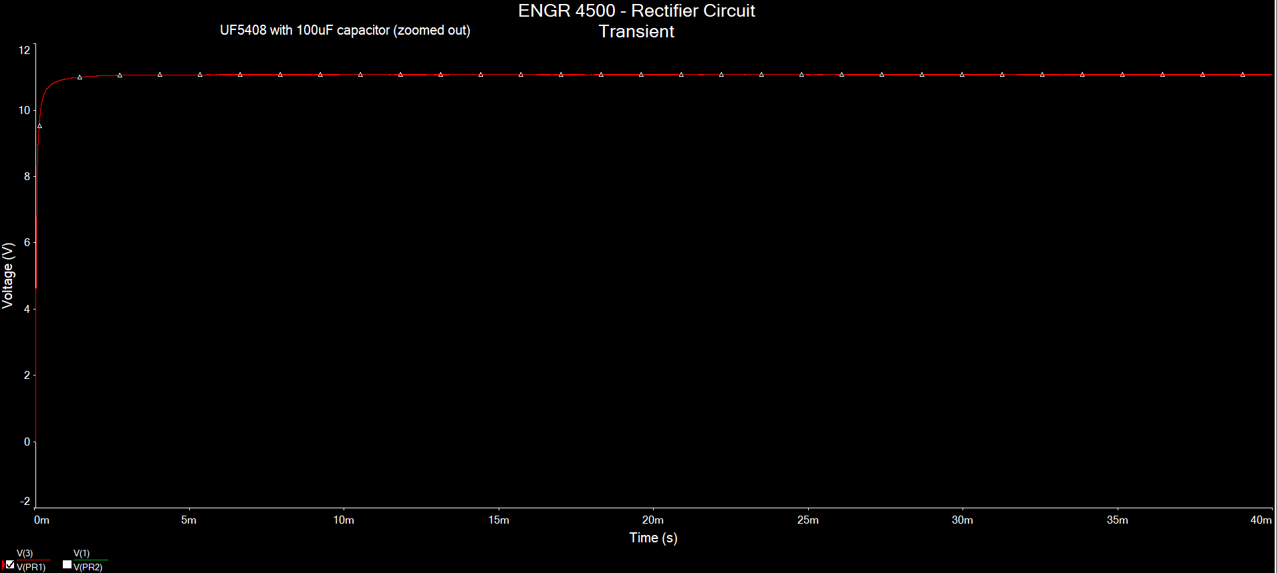

Changing the capacitance from 100uF to 500uF results in 11.05VDC

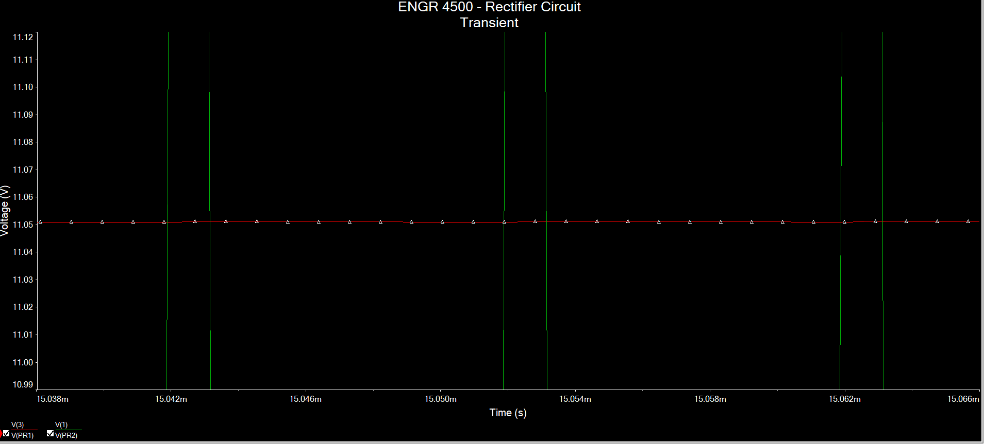

Changing the capacitance from 100uF to 50uF results in 11.06VDC

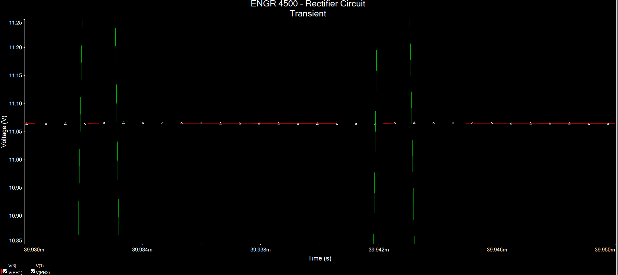

Changing the diode to 1N5402G (200V 3A Standard Rectifier Diode)

This result in a DC voltage of 11.18V for a 100uF capacitor

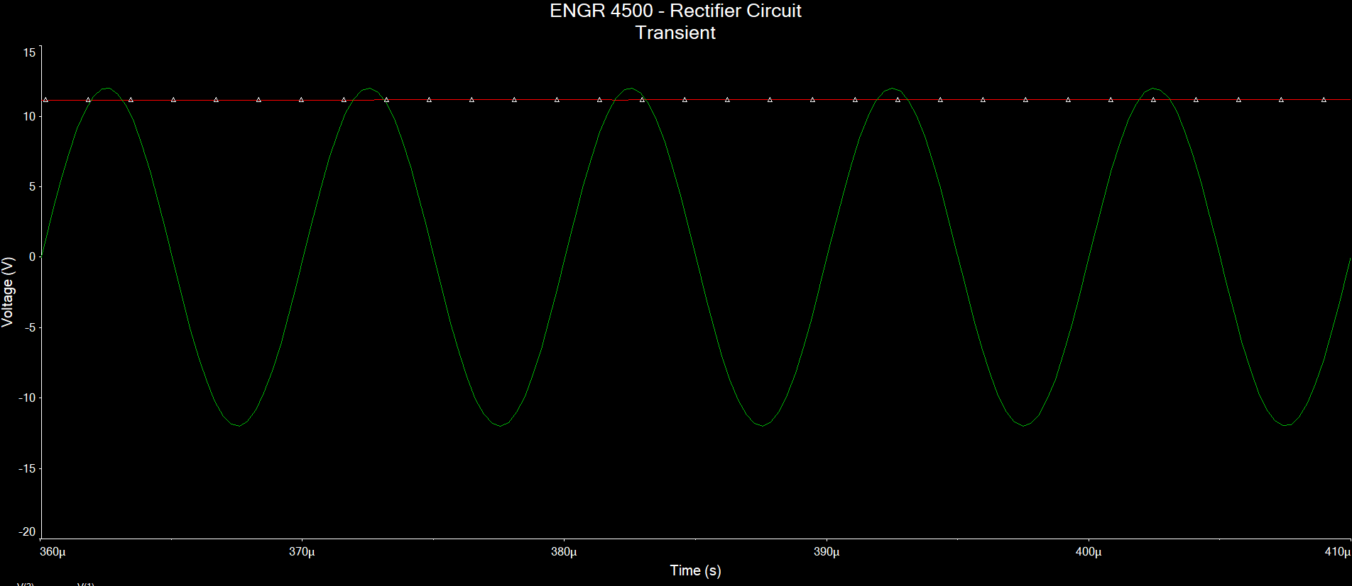

Changing the capacitance to 500uF results in 11.175VDC

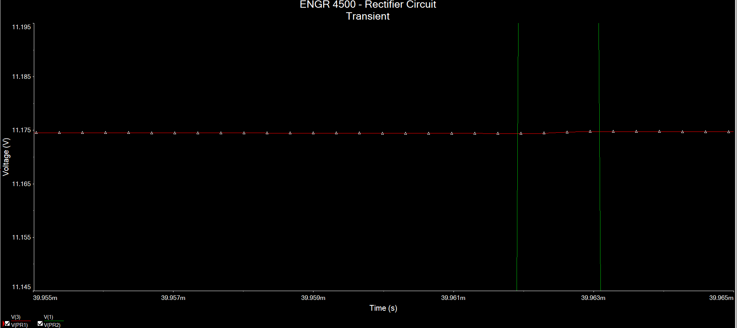

Changing the capacitance to 50uFresults in 11.175V

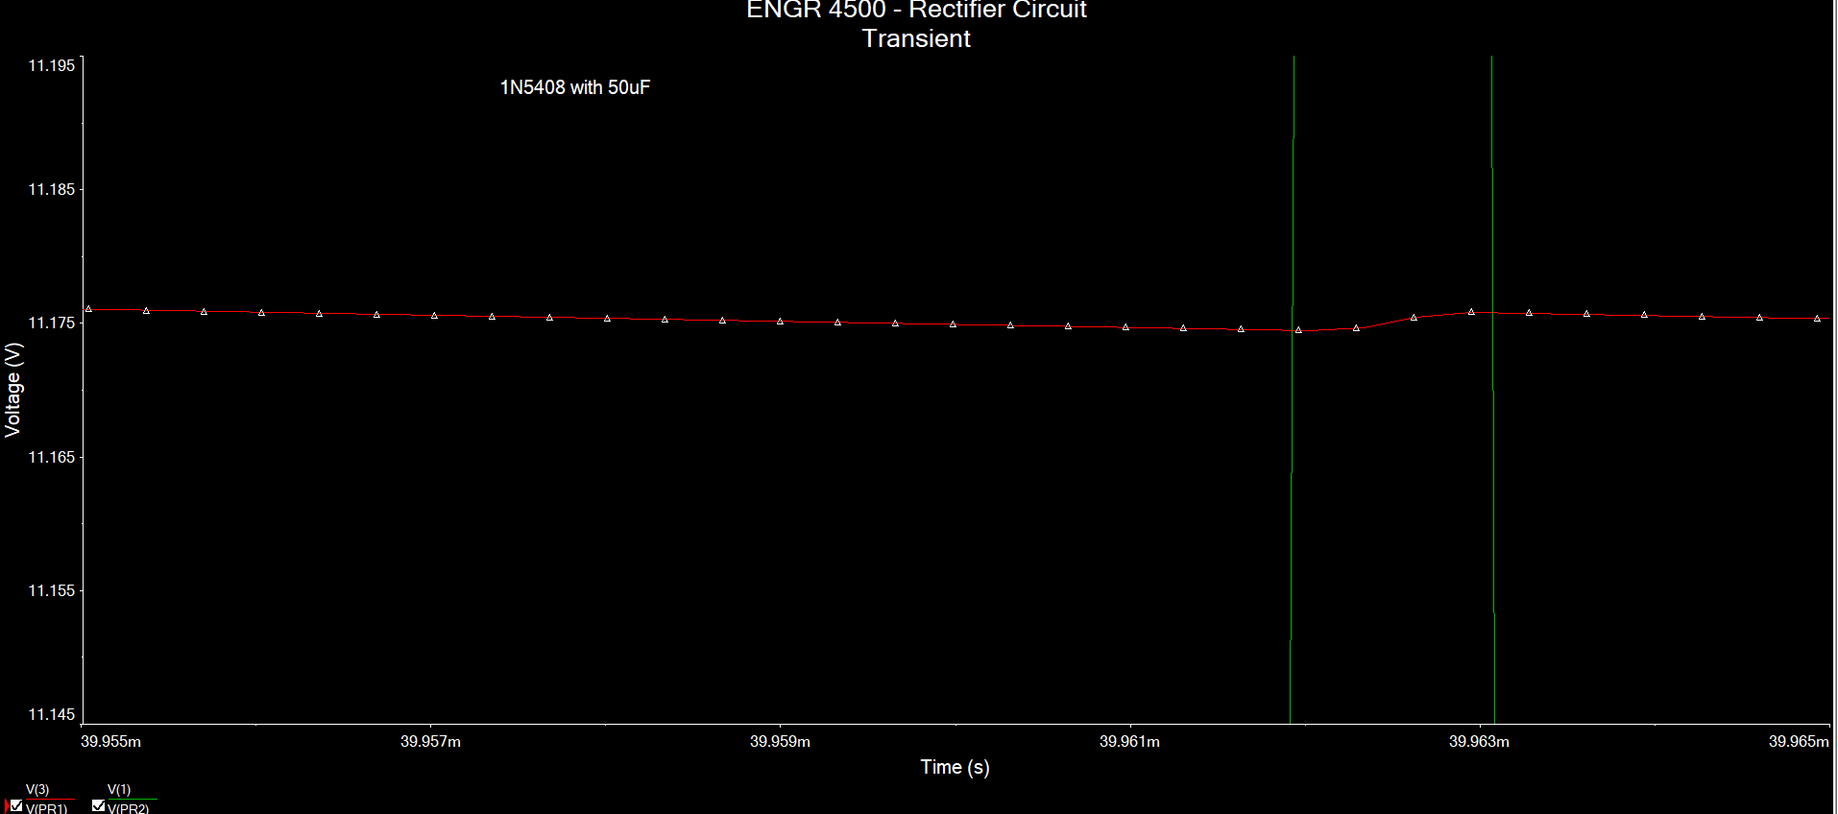

## Changing the Capacitance

Change the capacitance to 50nF from 25.33nF  
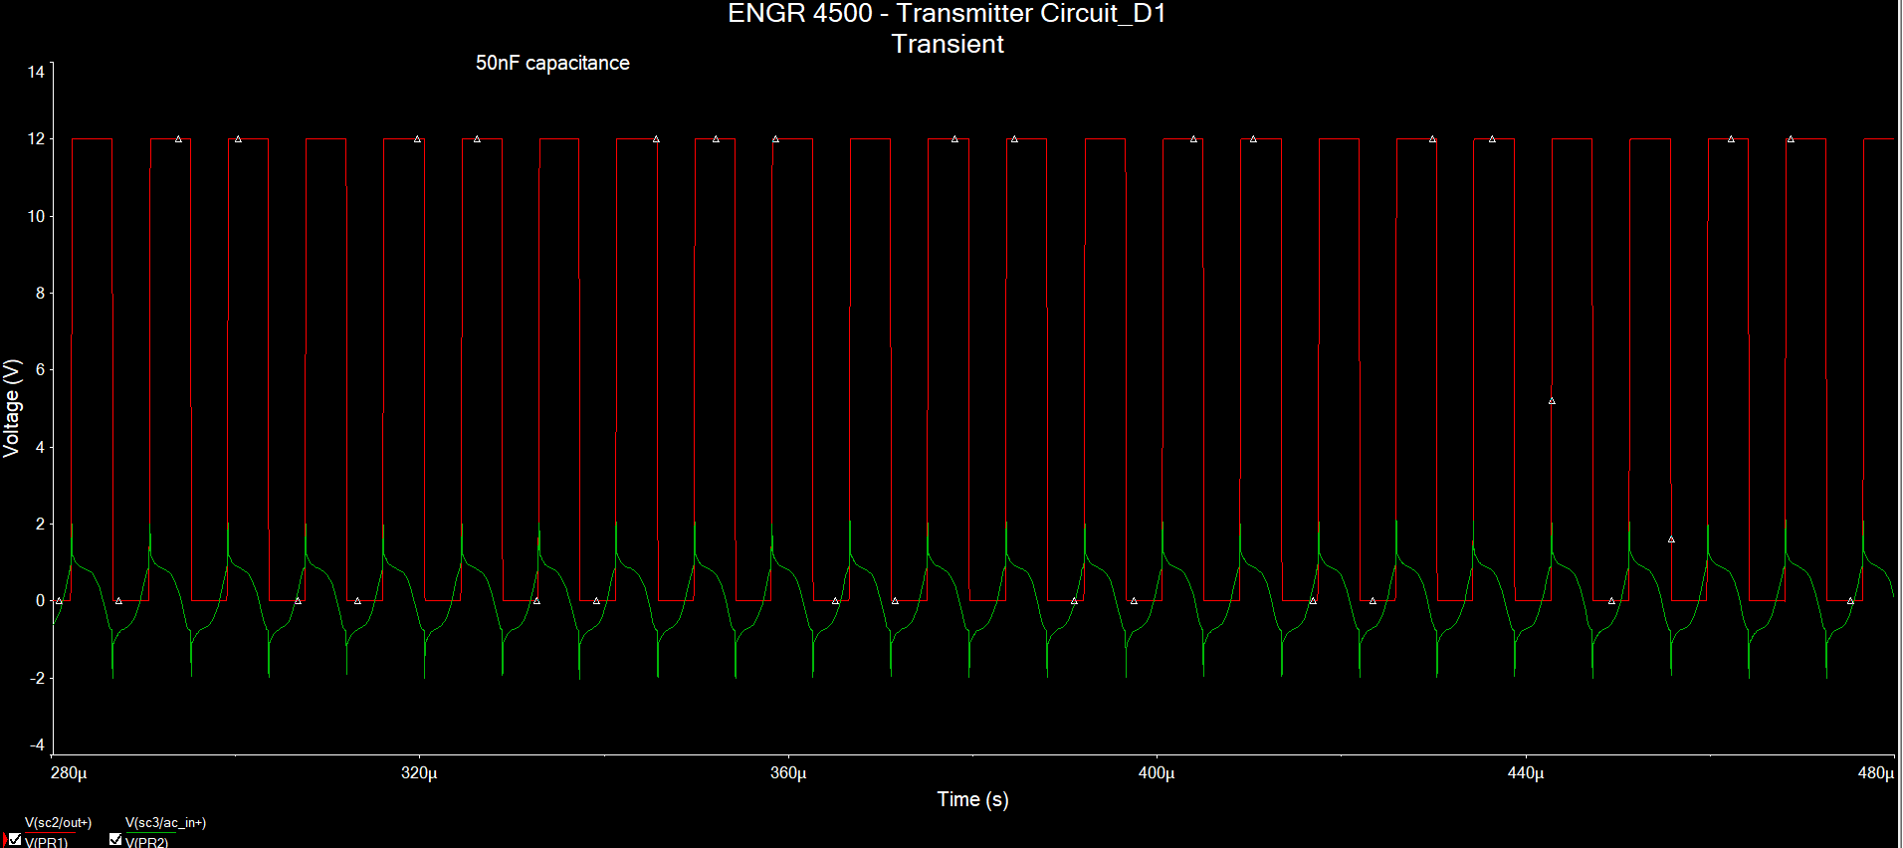

Changing the capacitance to 100nF from 25.33nF

Changing the capacitance to 10nF from 25.33nF

Changing the capacitance to 1nF from 25.33nF

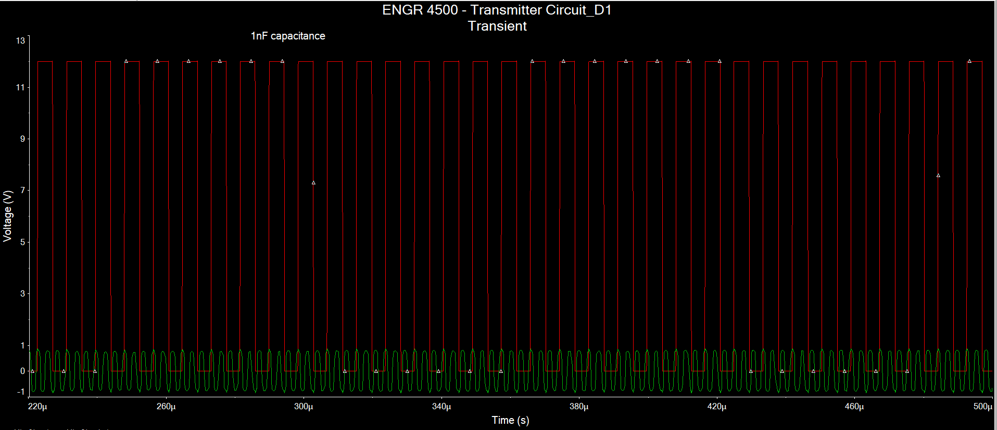

The limit seems to be 0.1nF for a 100uH system

25.33nF and k = 0.9

10nF and k=0.9

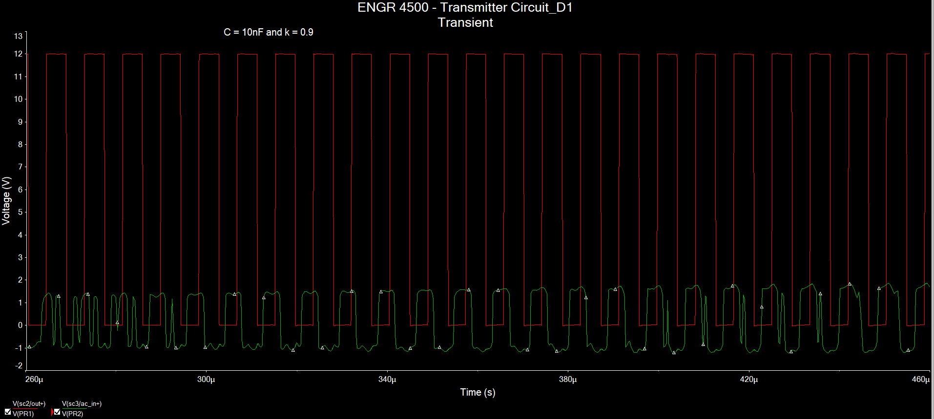

50nF and k=0.9

100nF and k=0.9

Looking at the load shows that the DC voltage does reach 12.1V at steady state

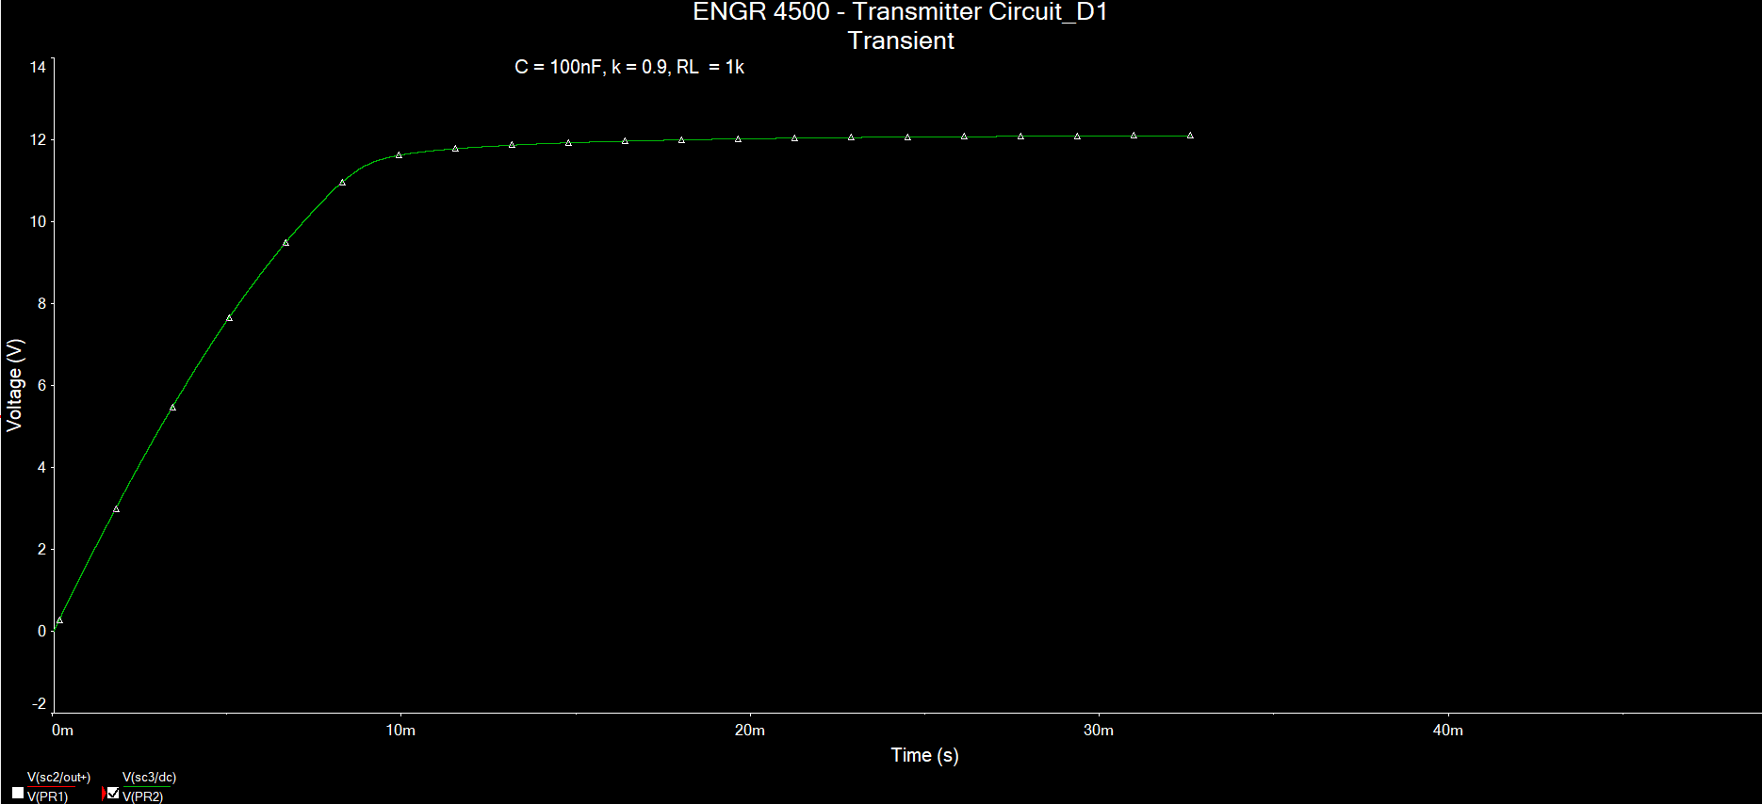Try it with 25.33nF, k = 0.9 does not reach the same result

Even with k = 0.5

## Changing the Inductance

Changing the inductance to 24uF (by Wurth Elektronik)

If L = 24uH

$$C=\frac{1}{4π^{2}f^{2}L}=\frac{1}{4π^{2}{\left(100kHz\right)}^{2}\left(24μH\right)}=105nF or 0.105μF$$

L = 24uH, C = 105nF at k = 0.9

C = 155nF, k = 0.9, L = 24uH

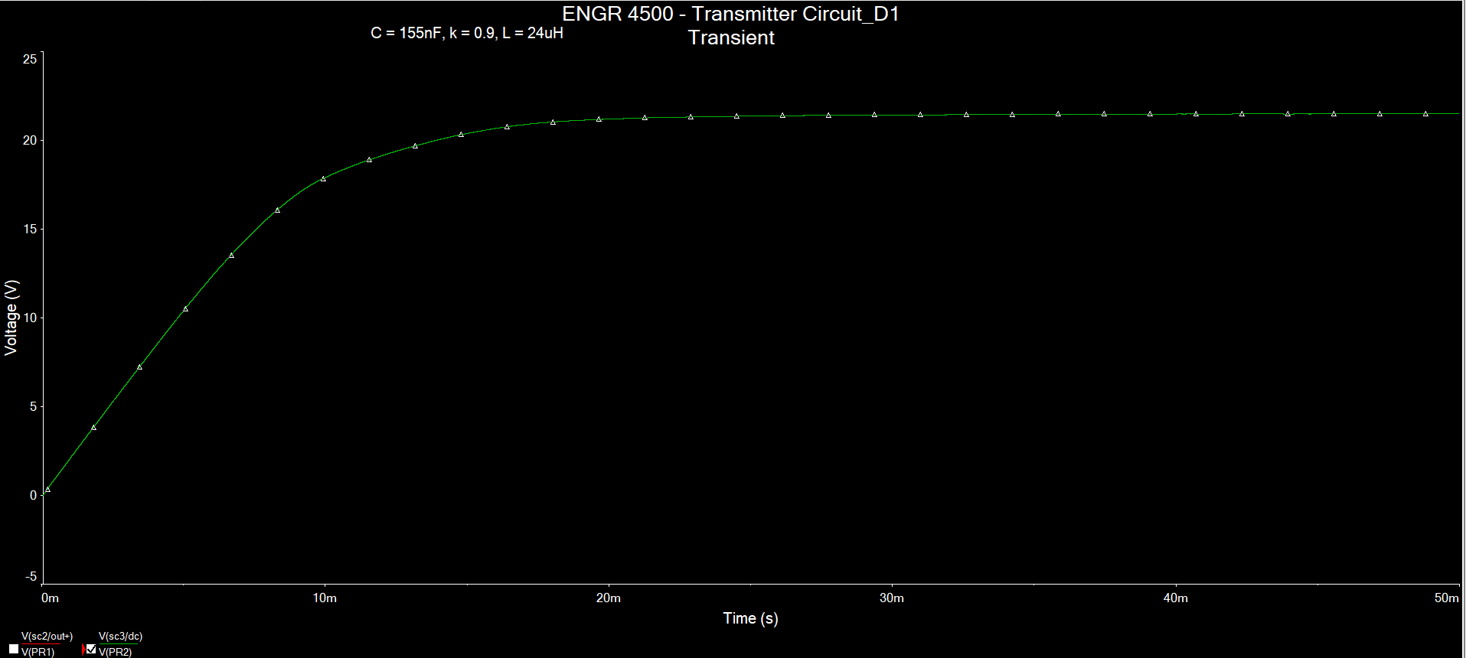

C = 422nF, k = 0.9, L =24uH

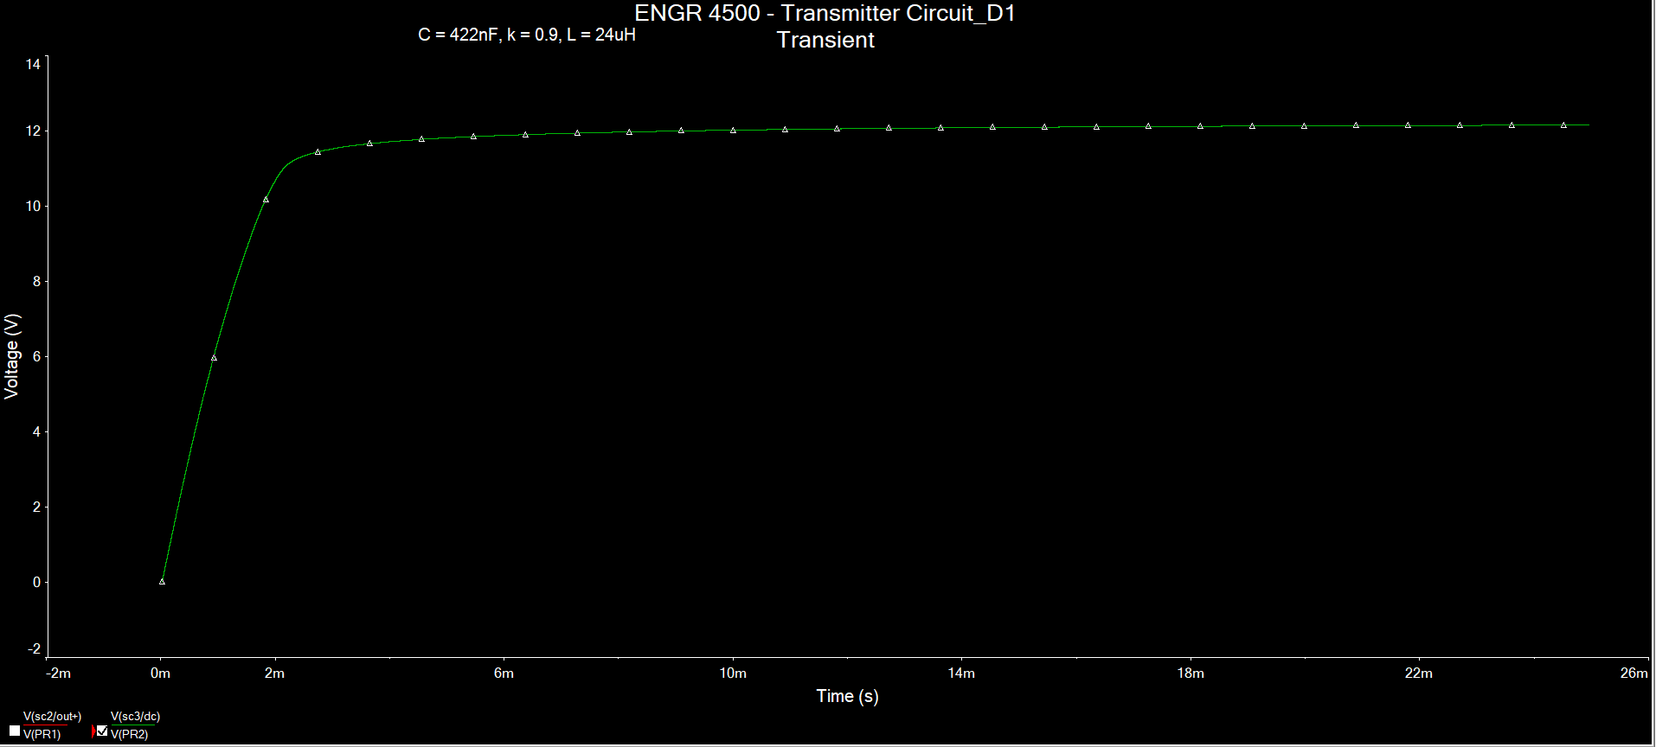

C = 55nF, L = 24uH, k = 0.9

So we need to check the H bridge with ideal components

## Checking the H Bridge Design with Ideal Components

C = 25.33nF, L = 100uH , k = 0.9

C = 100nF, L = 100uH, k = 0.9

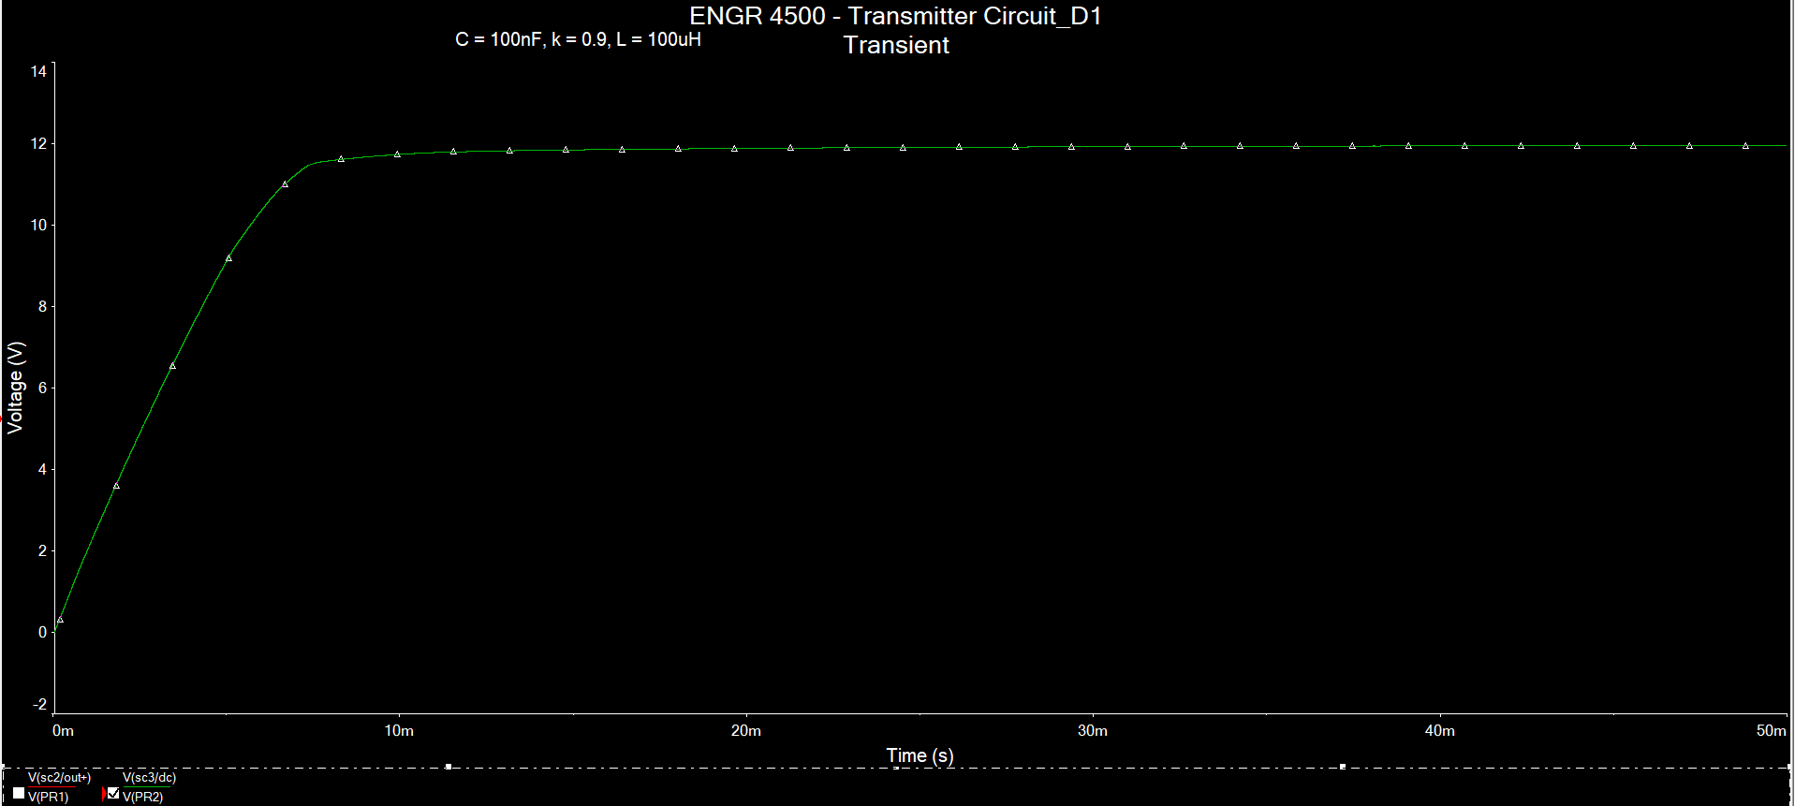

C = 105nF, L = 24uH, k = 0.9

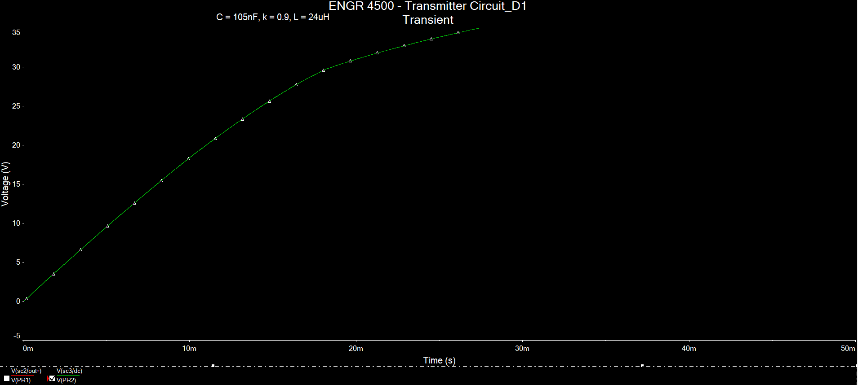

C = 422nF, L = 24uH, k = 0.9

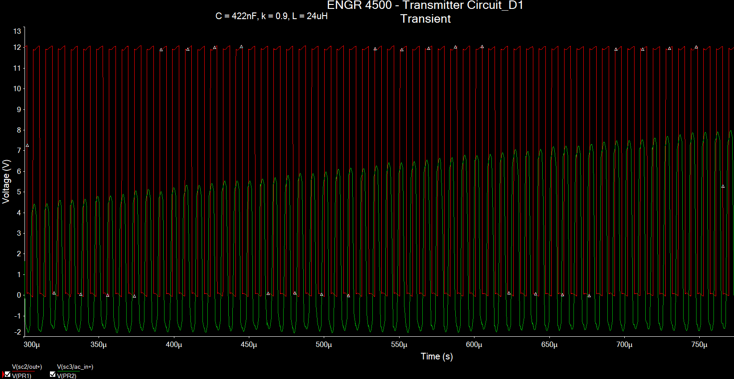

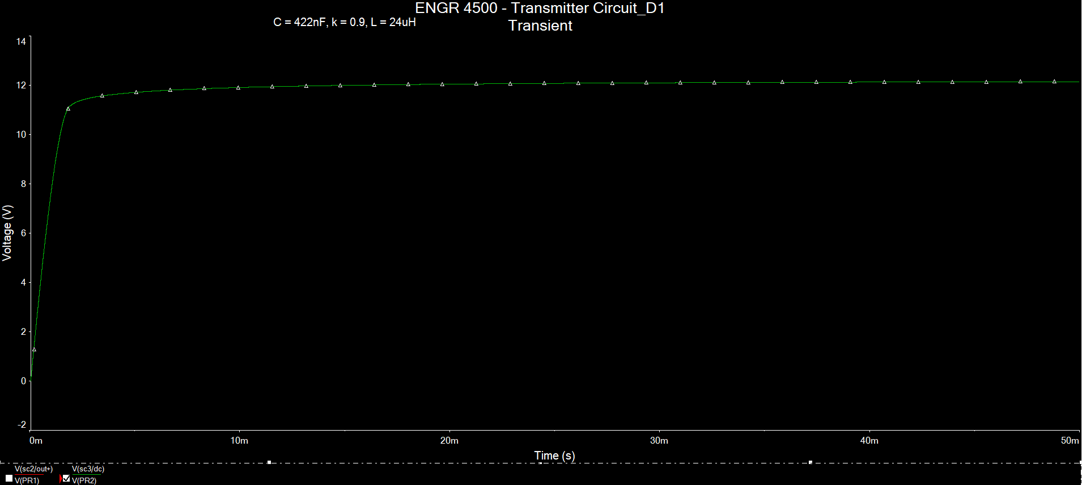

## Changing the PWM Generator with an Ideal Component

### Ideal 555 Timer

C = 25.33n, L = 100u, k = 0.9, Cr = 500u

### Multisim PWM Generator

For C = 25.33nF, L = 100u, k = 0.9, Cr = 500u

C = 100nF, L = 100u, k = 0.9, Cr = 500u

C = 200nF, L = 100u, k = 0.9, Cr = 500u

C = 150nF, L = 100u, k = 0.9, Cr = 500u

### Multisim Pulse Source

C = 25.33n, L = 100u, k = 0.9

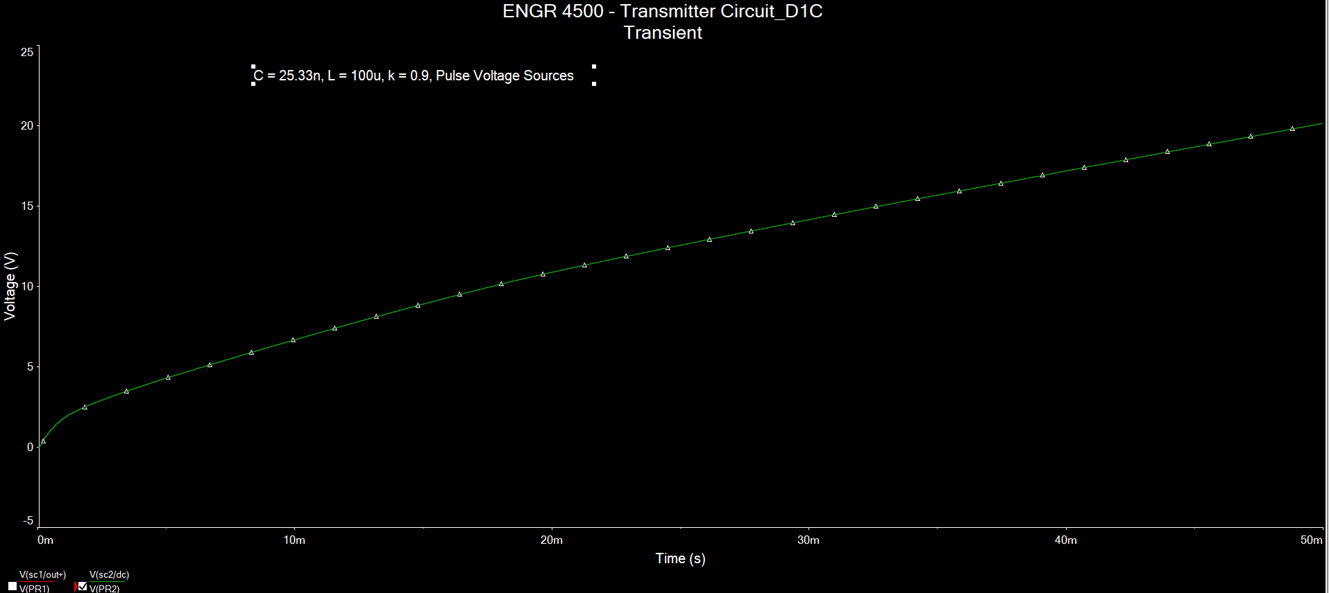

C = 100n, L = 100u, k = 0.9

C = 150n, L = 100u, k = 0.9

